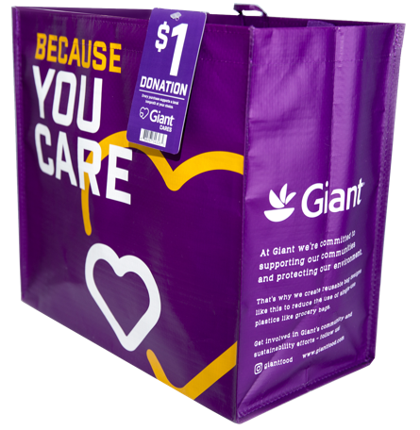
COMMUNITY BAG PROGRAM

Launch Day Email

DOWNLOAD IMAGES

SUBJECT: Launch Day: Giant Food Community Bag Program!

Hello,

Today is launch day for the Giant Food Community Bag Program! Starting today and for the entire month of [month of selection], when you purchase a $2.50 reusable Community Bag at the Giant Food located at [location], $1 is donated to [name of organization].

Our goal is to sell [goal of bags bought, e.g., 200] bags, equivalent to $[insert donation equivalent, e.g., $200] raised. We are confident that with the help of our dedicated supporters, we can reach this goal.

We strongly encourage you to share this news with family and friends as well!

The Community Bags are located on displays around the store and at the checkout. For more information about the program, please visit giantfood.2givelocal.com.

Thank you for your support,

[Signature]

giantfood.2givelocal.com

