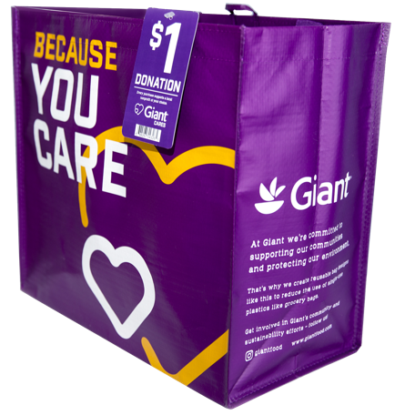

GIVING TAG PROGRAM

Sample Email

DOWNLOAD IMAGES
SUBJECT LINE: Buy a Bag, Fill Out the Tag and We’ll Get $1!

PREVIEW TEXT: Look for the Giving Tag on every reusable Community Bag purchased at Giant Food and direct $1 to us!

Dear [Staff/Board/Volunteers],

We are so excited to announce the Giant Food Giving Tag Program, which makes it easy for customers to direct donations to local organizations of their choice.

At any Giant Food, just purchase a $2.50 reusable Community Bag, follow the instructions on the Giving Tag that comes with it, select [organization] and we’ll receive a $1 donation!

Let’s get started! Share the news with friends and family. Call, send emails and post on social media. The more people who purchase the Community Bag and use the Giving Tag to direct the donation to [organization], the more we can raise!
To learn more about this program, please visit giantfood.2givelocal.com.
Best,
[Signature]

giantfood.2givelocal.com

