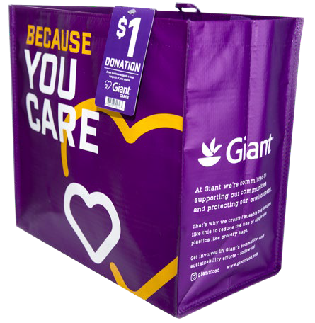
COMMUN ITY B AG PROG RAM

Announcement Email

SUBJECT LINE: We’ve been selected by the Giant Community Bag Program!

PREVIEW TEXT: During [Month], we will receive $1 for every reusable Community Bag purchased at Giant Food!

Dear [Staff/Board/Volunteers/Supporters],

We are so excited to share that, for the entire month of [month], [organization] has been selected by store leadership to benefit from the Giant Food Community Bag Program, which makes it easy for shoppers to contribute to their local communities.

During [month], whenever a $2.75 reusable Community Bag is purchased at the Giant Food located at [location], $1 will be donated to [organization]. This is a great way to broaden awareness and help our cause. Almost $575,000 has been donated to more than 1,700 nonprofit organizations since the program launched in July 2019.

Let’s get started! Share the news with friends and family. Call, send emails, and post on social media. The more people who purchase the Community Bag in [month], the larger the donation we will receive from Giant Food!

To learn more about this program, please visit giantfood.2givelocal.com.

Best, [Signature]

