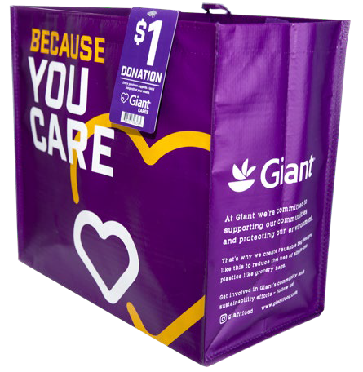



**COMMUNITY BAG PROGRAM**

Fact Sheet

Congratulations on your organization’s selection in the Giant Food Community Bag Program!

**Not sure how to start talking about the program? We’re here to help!** We’ve brought together key facts and talking points from across the program website compiled in one place. Below you will find information you can use to discuss this program with your board, staff, and supporters:

1. The Giant Food Community Bag Program has been operating since July 1, 2019.
2. Since inception, the program has donated $781,903 to 1,939 nonprofit organizations and sold 781,888 reusable bags.*
3. Giant Food operates 163 stores across Delaware, Maryland, Virginia, and the District of Columbia. All stores participate in the program.
4. The Giant Food Community Bag Program makes it easy for shoppers to support their communities and environment by buying durable, reusable shopping bags. A portion of each purchase goes to a local nonprofit organization focused on Hunger Relief, Education (all aspects), Health & Wellness, Civic activities, or Military/Veterans affairs.
5. Every month, the Store Leadership Team at each Giant Food location or the Community Relations Team chooses a local nonprofit to be the monthlong beneficiary of the Community Bag Program in that store. Different nonprofits are selected every month to ensure the many organizations making a difference in our local communities can be supported by this program.
6. Generally, the nonprofits selected by a specific store are within a 10-mile radius of that store location. It’s important to note that this program benefits each store’s regional shopping area.

________________________________________

*\*As of 5.11.25. These statistics are updated daily on the program website and can be found* [[***here***](https://giantfood.2givelocal.com/program/community-bag/)](https://giantfood.2givelocal.com/program/community-bag/)*. You will want to use the most recent stats available at the time of your selection.*

**Page 2**

1. Each bag costs $2.75, with $1 of that purchase going to support a benefiting nonprofit in your community.
2. Nonprofits meeting the [**program's qualifications**](https://giantfood.2givelocal.com/submit-your-organization/) are submitted to our database of thoroughly researched organizations within the vicinity of each store location
3. A list of nonprofit organizations that have benefited from the Community Bag Program can be found [[**here**](https://giantfood.2givelocal.com/community-impact-by-non-profit/)](https://giantfood.2givelocal.com/community-impact-by-non-profit/) on the program website and is organized alphabetically.
4. The bags are made from 95% recycled materials from either nonwoven or woven polypropylene. They are manufactured in Vietnam in factories that follow the strictest guidelines for employment and production standards.

*Published 5.11.25*