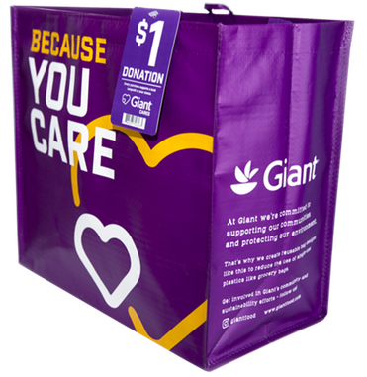



**COMMUNITY BAG PROGRAM**

Announcement Email

& Social Post

**SUBJECT LINE:** We’ve been selected to partner with the Giant Food Community Bag Program!

**PREVIEW TEXT:** During [*Month*], we receive $1 for every reusable Community Bag purchased at our selected Giant Food location!

Dear [*Staff/Board/Volunteers/Supporters*],

We are excited to share that Giant Food has selected [*organization*] to benefit from the Community Bag Program throughout [*month*]. The Giant Food Community Bag Program makes it easy for shoppers to contribute to their local communities.

Every time a $2.75 reusable Community Bag is purchased at the Giant Food located at [*location*] in [*month*], $1 will be donated to [*organization*]. This is a great way to broaden awareness of our mission and help our cause.

Let’s get started! Share the news with friends and family. Call, send emails, and post on social media. The more people who purchase a Community Bag in [*month*], the greater the donation we will receive from Giant Food!

For more information about the program, please visit [giantfood.2givelocal.com](https://giantfood.2givelocal.com).

Best,

[*Signature*]



**Share With Your Followers**

**We’re excited that Giant Food has selected our organization to benefit from the Community Bag Program! Throughout [*month*], we will receive a $1 donation for every $2.75 reusable Community Bag purchased at the Giant Food located at [*address of selected store(s)*].**