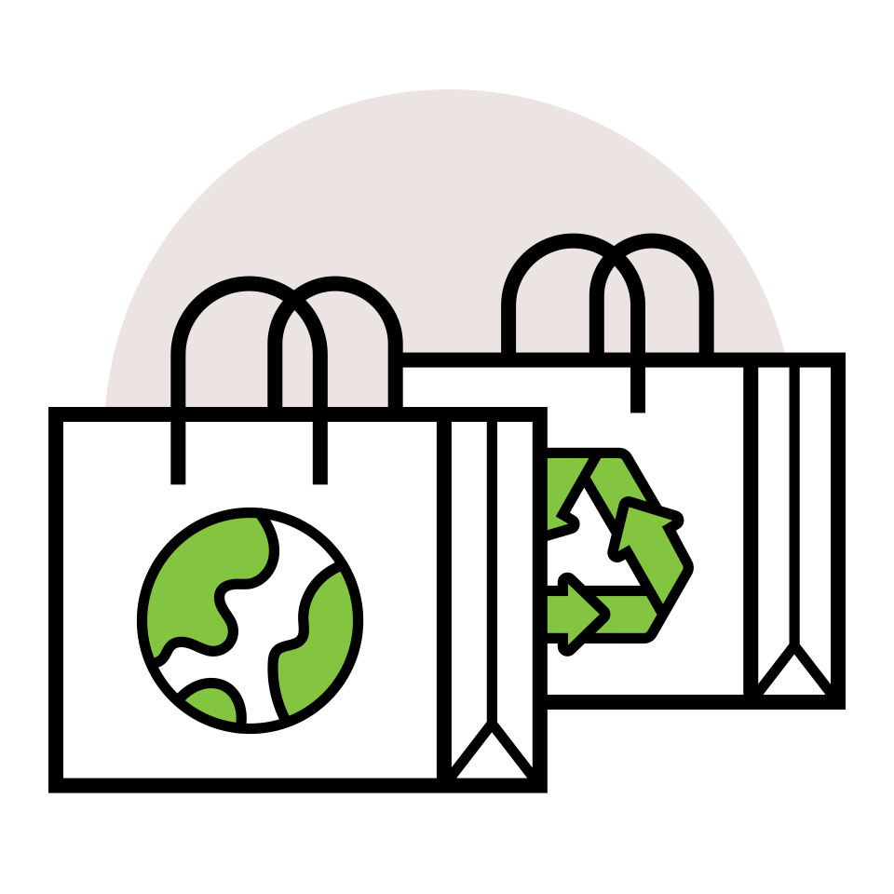

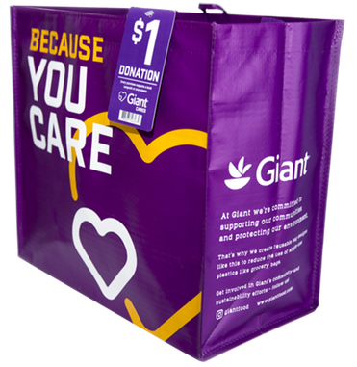

COMMUNITY BAG PROGRAM

Reminder Email

**SUBJECT:** We have *[insert number of weeks or other time frame]* weeks remaining  
in our Giant Food Community Bag Program partnership!

**PREVIEW TEXT:** There’s still time to maximize this opportunity for our cause!

Good morning,

We've reached [*or We will shortly reach*] the halfway point in our [*insert month*] partnership with the Giant Food Community Bag Program. This is a wonderful opportunity to raise funds for our organization and to spark positive change in our community!

Remember, for every $2.75 reusable Community Bag purchased in any Giant Food location this month, we'll receive $1. Every bag counts, so let's maximize this opportunity!

Please spread the word to your friends and family. Let's encourage everyone to look for the Giant Food Community Bags in their local store this month. There’s still time left to make a difference!

For more information about this impactful program, please visit [giantfood.2givelocal.com](https://giantfood.2givelocal.com/).

Thank you for your support!

Best,

[*Signature*]